* **Backup Prerequisites:**

Take the backup of **SHAW_INV_TRANSACTIONS_PKG** package specification (.pks) and package body from Production database.

Take the backup of **SHAW_OM_POS_LGF_PKG** package specification (.pks) and package body (.pkb) from Production database.

Take the backup of **TYPE SHAW_OM_POS_INS_REC** from Production database.

* Go to the URL:- <https://shawicsprod-a444774.integration.us2.oraclecloud.com/ics/>
* Enter the credentials and login
* Go to Task – Integrations – Designer – Lookups
* Search for lookup – “**SHAW_Logfire_Common_Lookup**” and **Export to CSV** the file as shown below.

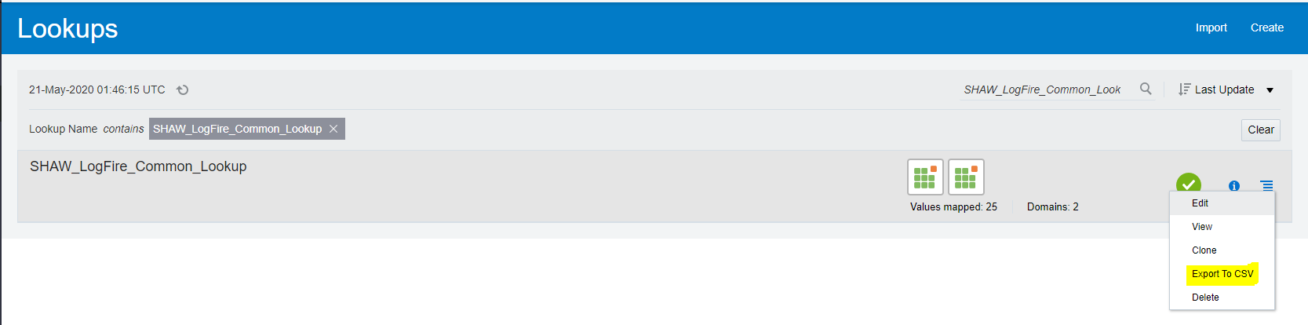

* Backup of the integrations is completed, and you can proceed with the migration.
* **Prerequisite migration steps:**
* Go to the URL:- <https://shawicsprod-a444774.integration.us2.oraclecloud.com/ics/>
* Enter the credentials and login.
* Go to Task – Integrations – Designer - Integrations

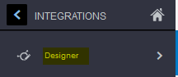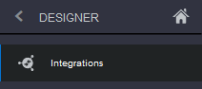



* Search for Integration – “**Shaw Logfire Master Scheduler Integration**”
* Go to Actions and click on Schedule: 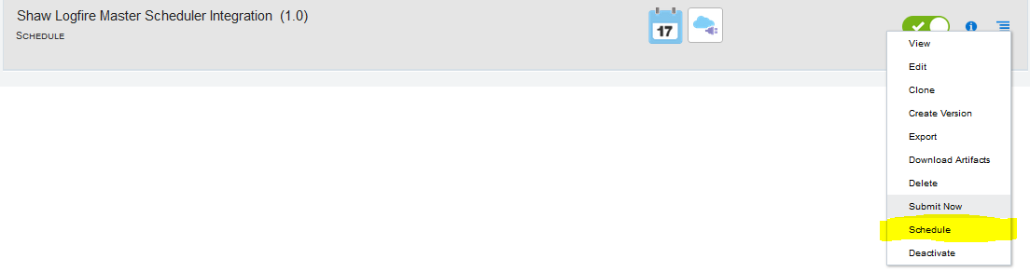
* Click on Stop Schedule and Close

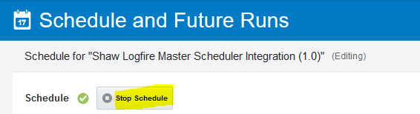

* Search for Integration – “SHAW OM PointOfSales From Cloud to LogFire”
* Deactivate the Integration.

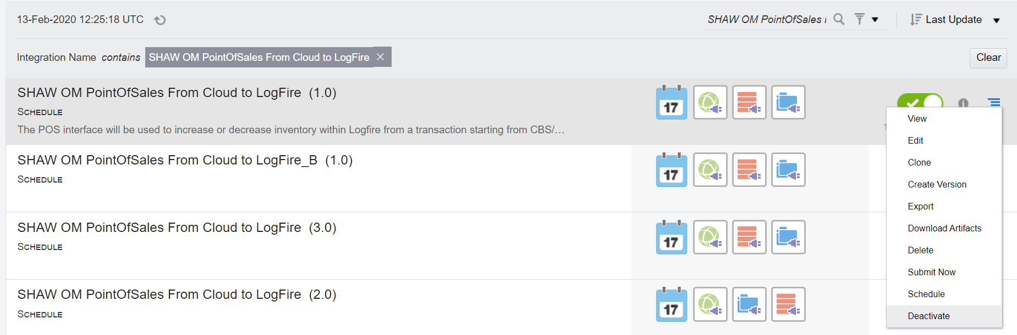



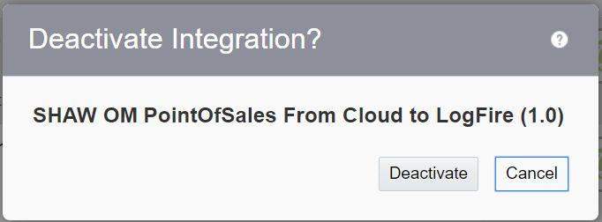



* **Installation:**
* Open Production DBCS connection in SQL Developer/Toad.
* Go to the following GIT path:
* Compile the Script:

cloud-erp\Interfaces\ LOG-INT-18\Developed Components\DB \ **SHAW_OM_POS_LOGFIRE_STG_ALTER.sql**

* Compile the package specification:

cloud-erp\Interfaces\LOG-INT-18\Developed Components\DB\**SHAW_OM_POS_LGF_PKG.pks**

* Compile the package body:

cloud-erp\Interfaces\LOG-INT-18\Developed Components\DB\**SHAW_OM_POS_LGF_PKG.pkb**

* Compile the package body:

cloud-erp\Interfaces\LOG-INT-11-22-23\Developed Components\DB \**SHAW_INV_TRANSACTIONS_PKG.pkb**

* Check all the dependent DB object are valid.

select * from all_objects where object_name in('SHAW_INV_TRANSACTIONS_STG','SHAW_INV_TRANSACTIONS_STG_N14','SHAW_OM_POS_LOGFIRE_STG','SHAW_OM_POS_TRANSACTION_ID_S','SHAW_OM_POS_INS_REC','SHAW_OM_POS_INS_TAB','SHAW_OM_POS_LGF_PKG','SHAW_INV_TRANSACTIONS_PKG');

* **Add the BI Reports to ERP**
  + **STEP 1:** Add Data Model to ERP
  + Get the latest version of the Data Model from GIT:

cloud-erp\Interfaces\LOG-INT-18\ Developed Components\Reports\ **SHAW_ERP_POS_DM.xdm.catalog**

* + Go to ERP Cloud

URL: - <https://eguh.fa.us2.oraclecloud.com/analytics>

Enter the credentials and login.

* + Click on ‘Catalog’ on top of the screen

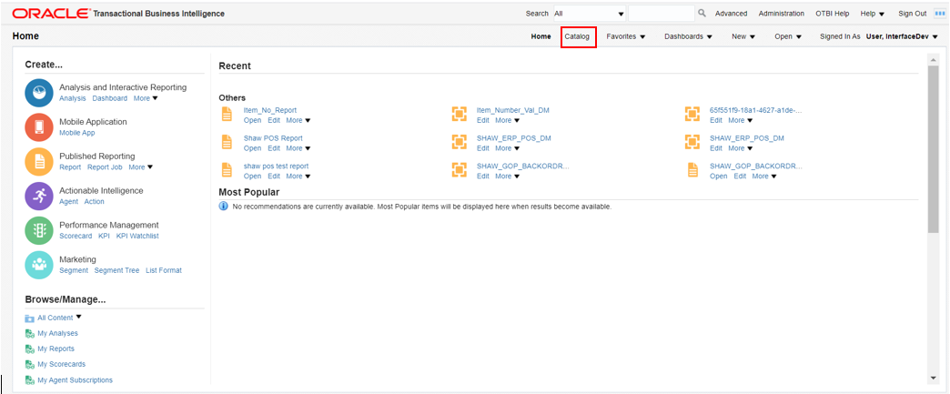

* + From the left side of the screen, navigate to the folder

/Shared Folders/Custom/Shaw Custom/Integrations/QueryService/Data Model

* + Click on **Unarchive** and browse the Data Model: “**SHAW_ERP_POS_DM.xdm.catalog**” to upload to ERP

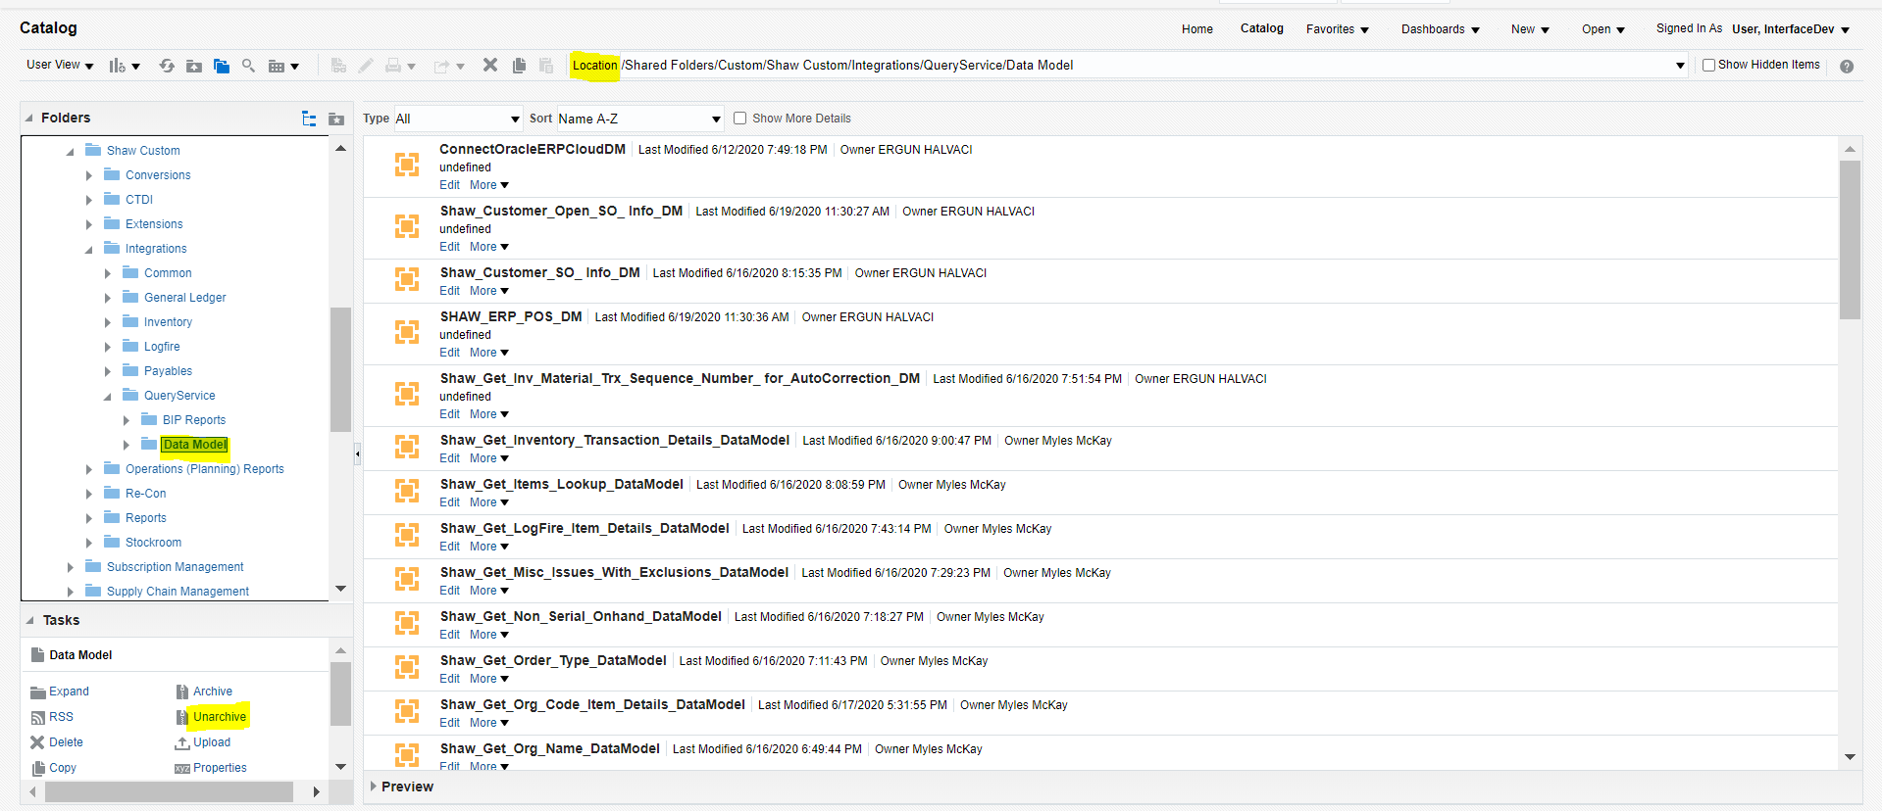

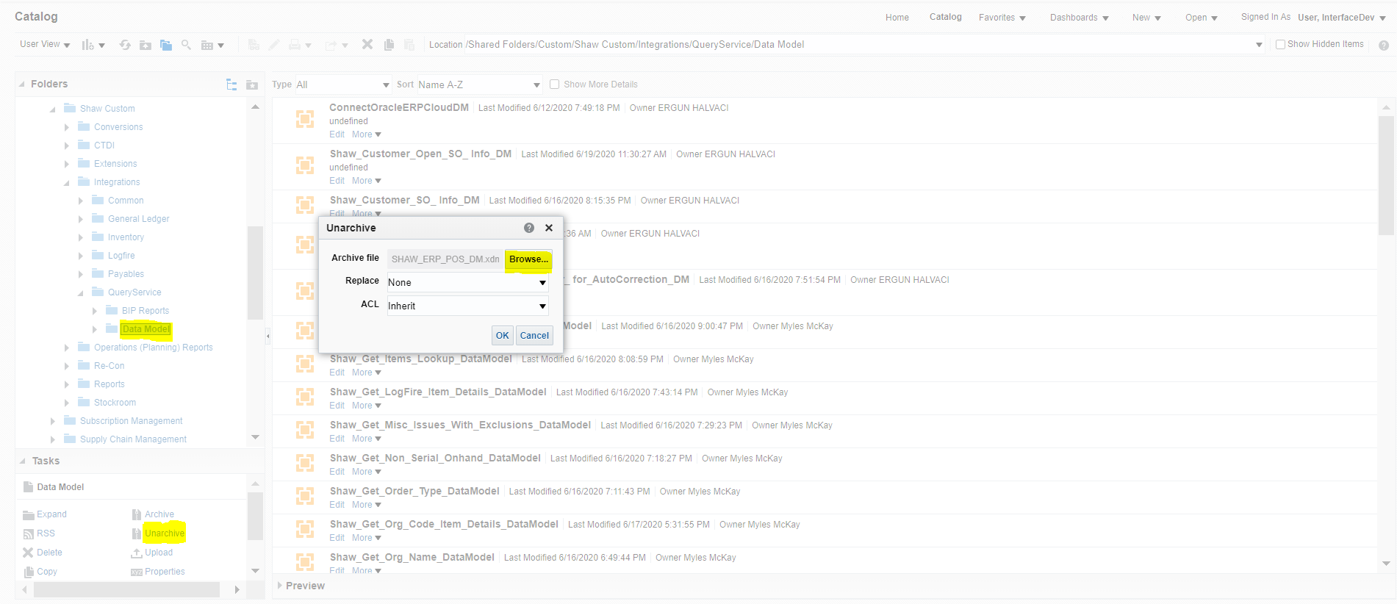

* + - Click OK.
* **STEP 2:** Add BI Reports
  + Get the latest version of the BI Reports from GIT:

cloud-erp\Interfaces\LOG-INT-18\ Developed Components\Reports\ **Shaw POS Report.xdo.catalog**

* + From the left side of the screen, navigate to the folder

/Shared Folders/Custom/Shaw Custom/Integrations/QueryService/BIP Reports

* + Go to BI Reports screen:

Click on **Unarchive** and browse the BI Report: “**Shaw POS Report.xdo.catalog**” to upload.

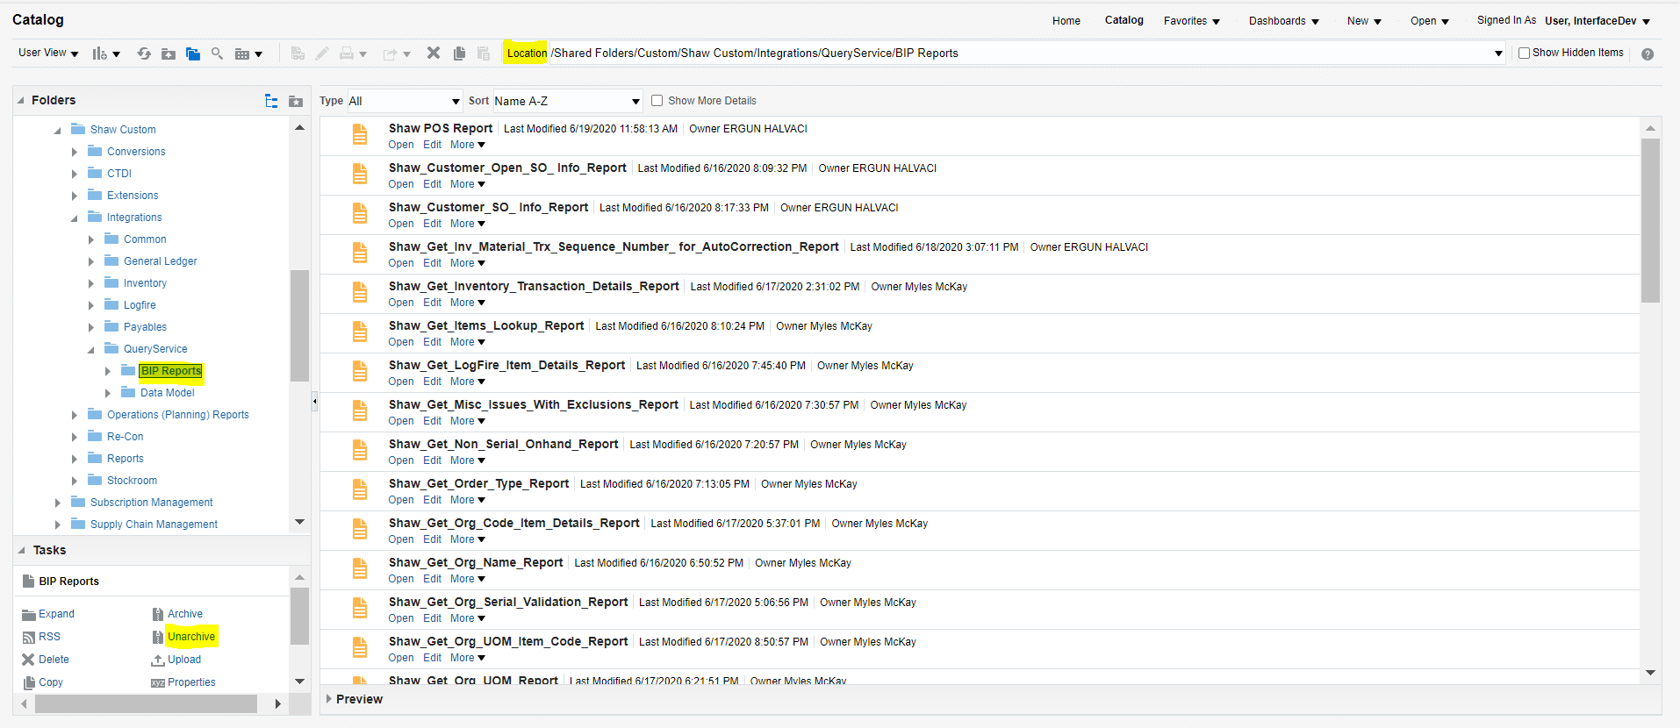

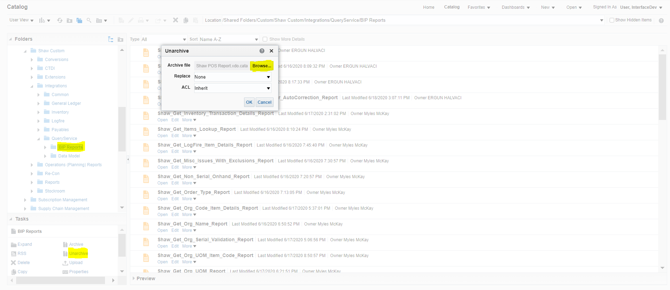

* + - * Click OK.
* **STEP 3:** Assign the BI Reports to Data Models
  + From the left side of the screen, navigate to the folder

Navigate to the following path in ERP:

/Shared Folders/Custom/Shaw Custom/Integrations/QueryService/BIP Reports/ **Shaw POS Report**

Select the Report “**Shaw POS Report**” and Click on ‘**Edit**’

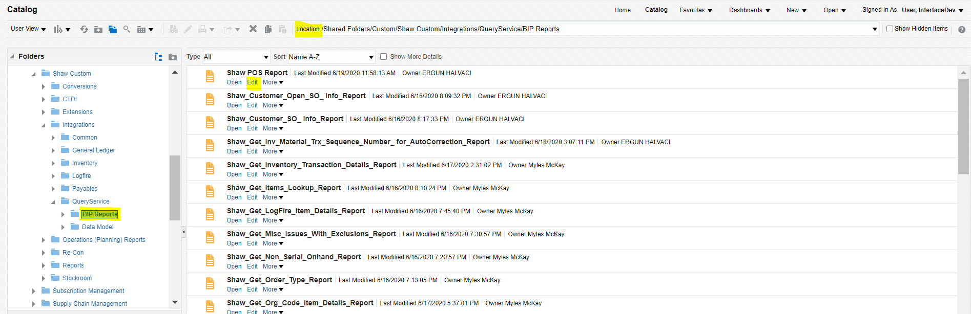

* Click search icon on top of the screen

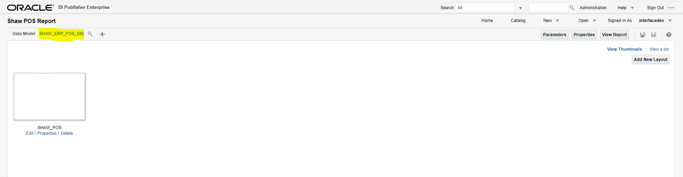

* Browse the Data Model to select the BI Report by navigating to the following path:

/Shared Folders/Custom/Shaw Custom/Integrations/QueryService/Data Model/**SHAW_ERP_POS_DM**

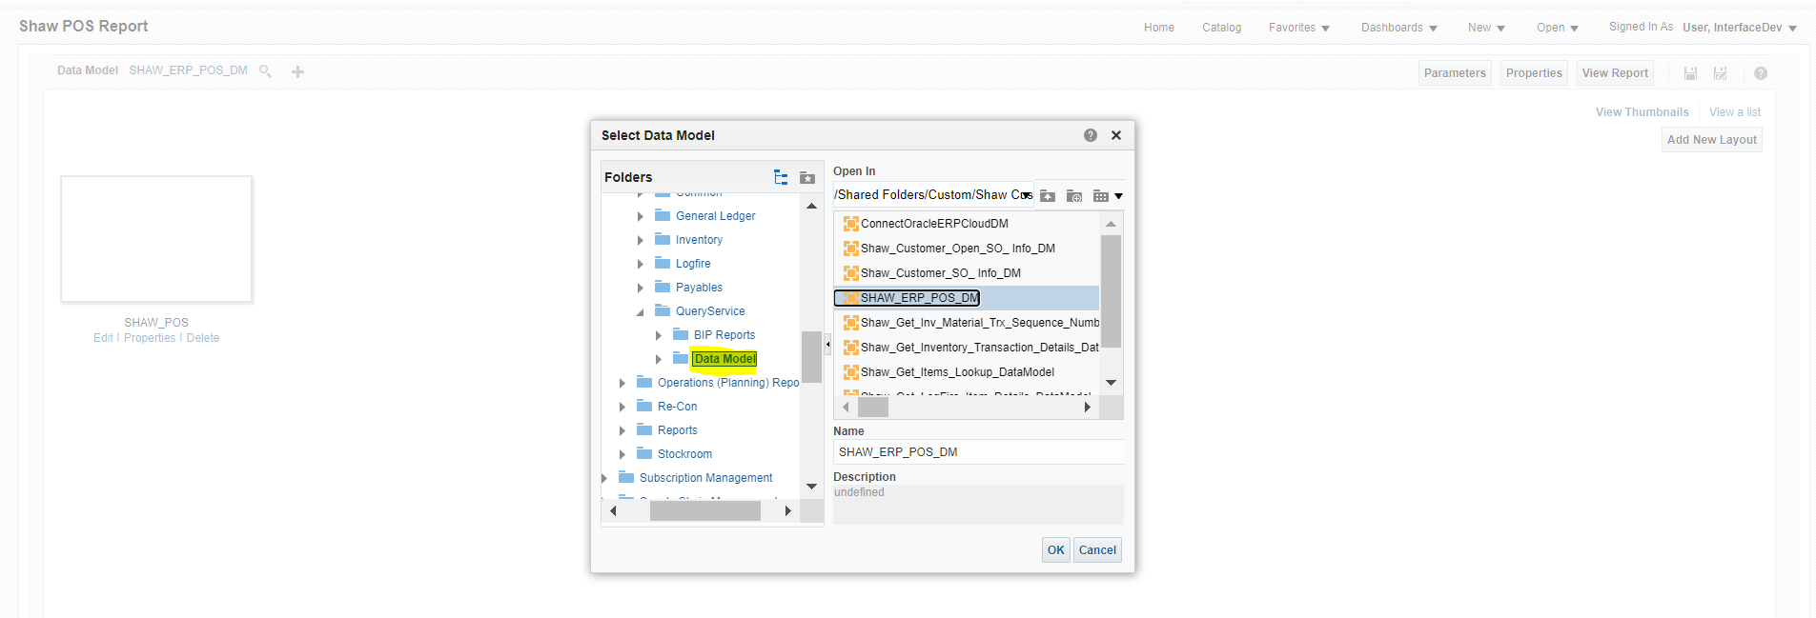

* Click Ok.
* Click on “Save” icon on the right side of the screen.

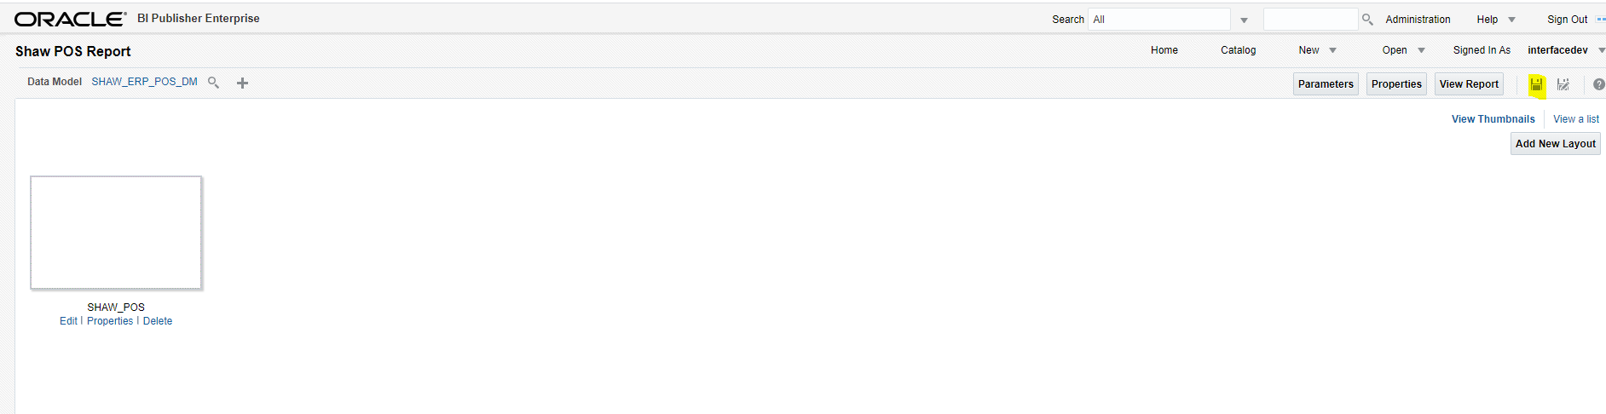

**ICS Installation steps:**

* Go to the URL:- <https://shawicsprod-a444774.integration.us2.oraclecloud.com/ics/>
* Enter the credentials and login

Go to Task – Integrations – Designer – Lookups and click Import as below

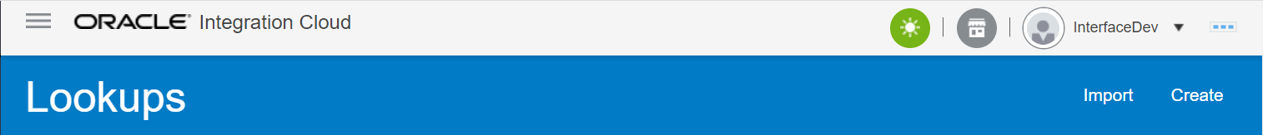



* Get latest csv from Git

**cloud-erp\Interfaces\LGF_COMMON\ICS \SHAW_Logfire_Common_Lookup.csv**

* Click on Browse, select that csv and click on import

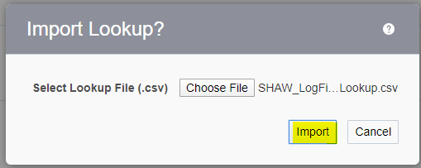

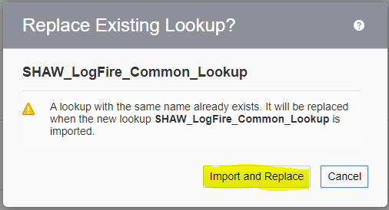



* Get the latest iar file from Git with the latest version.

cloud-erp\Interfaces\LOG-INT-18\ Developed Components\ICS

**SHAW_OM_POIN_FROM_CLOU_TO_DBCS_01.00.0000.iar**

cloud-erp\Interfaces\LOG-INT-18\ Developed Components\ICS **SHAW_OM_POIN_FROM_DBCS_TO_LOGF_01.00.0000.iar**

* Go to the URL:- <https://shawicsprod-a444774.integration.us2.oraclecloud.com/ics/>
* Enter the credentials and login

Go to Task – Integrations – Designer – Integrations and click Import:

**SHAW_OM_POIN_FROM_CLOU_TO_DBCS_01.00.0000.iar**



* Select the .iar file and click import

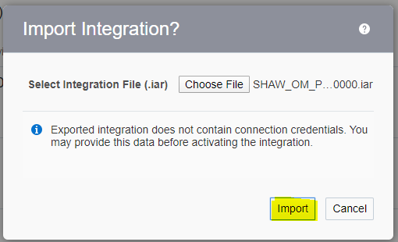

* Once imported Successfully, Activate the Integration: “**SHAW OM PointOfSales From Cloud to DBCS**”,

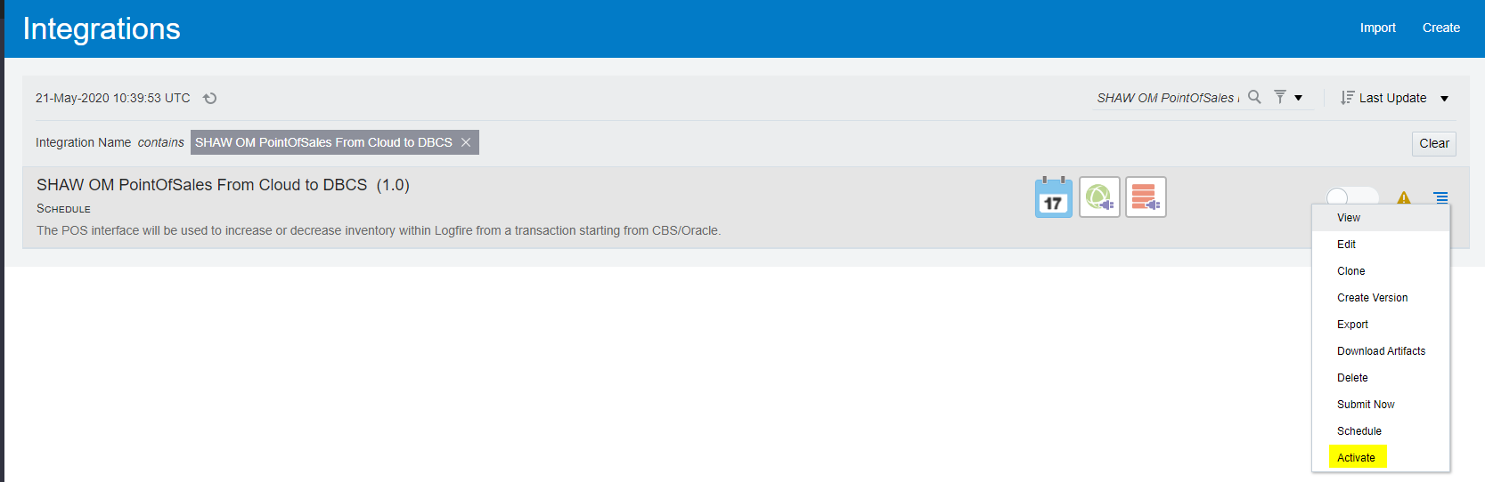

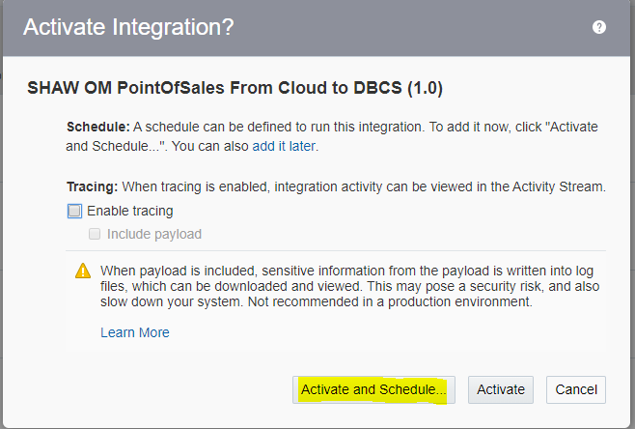

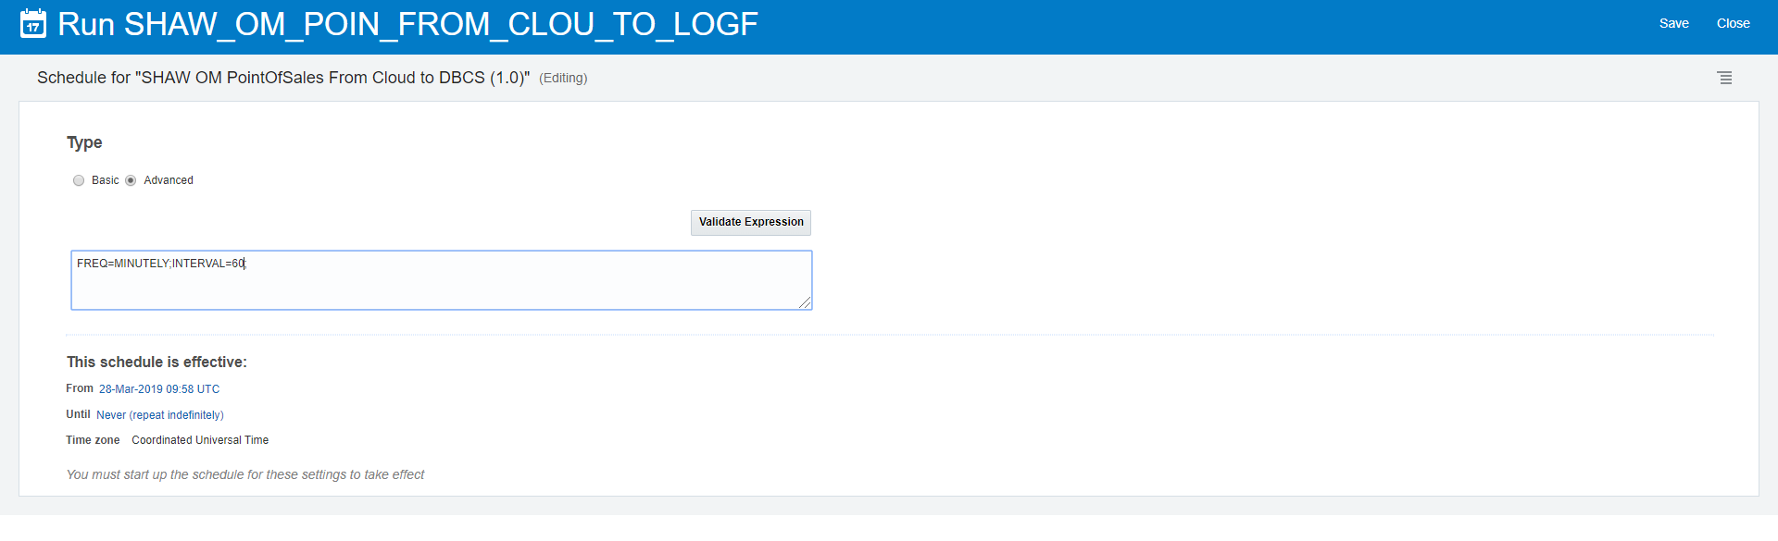

FREQ=MINUTELY;INTERVAL=60;

Click Save

* Follow similar steps for “**SHAW OM PointOfSales From DBCS to Logfire**” integration.

Go to Task – Integrations – Designer – Integrations and click Import: **SHAW_OM_POIN_FROM_DBCS_TO_LOGF_01.00.0000.iar**



* Select the .iar file and click import



* Once imported Successfully, Activate the Integration “**SHAW OM PointOfSales From DBCS to Logfire**”

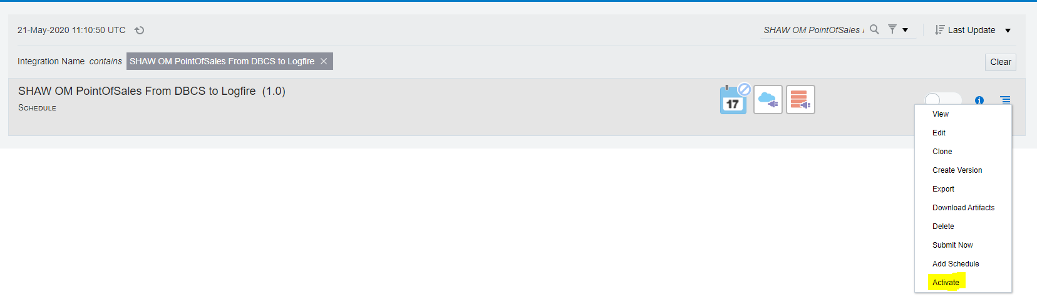

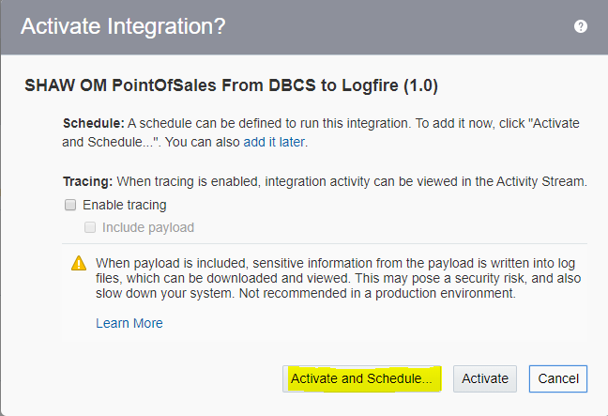

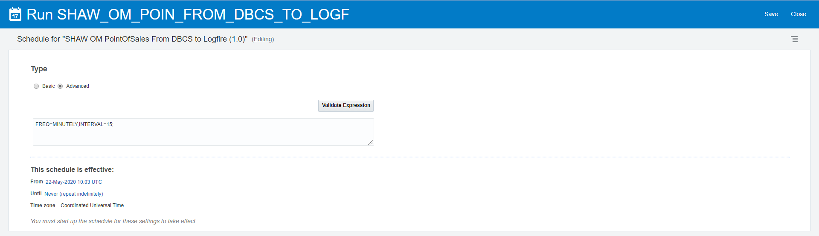

FREQ=MINUTELY;INTERVAL=15;

Click ok

* **Post Installation Steps:**
* Resume the Schedule for Master Integration by following the similar steps which is followed in stopping the schedule.
* Go to the URL :- <https://shawicsprod-a444774.integration.us2.oraclecloud.com/ics/>
* Enter the credentials and login
* Go to Task – Integrations – Designer - Integrations
* Search for Integration – “**Shaw Logfire Master Scheduler Integration**”
* Go to Actions (Hamburger button) and click on Schedule.
* Click on Start Schedule.



* **Recovery Steps**

In case of any issues follow the below steps to recover back to the old code. Use the backup code for the below steps.

* Follow **Prerequisite migration steps** to deactivate master schedular integration.

Run the below sql statements in TOAD/SQL Developer to drop the newly added column, new package and table types in DBCS:

* ALTER TABLE XXSHAW.SHAW_INV_TRANSACTIONS_STG DROP COLUMN POS_STATUS;
* DROP INDEX SHAW_INV_TRANSACTIONS_STG_N14;
* ALTER TABLE XXSHAW.SHAW_OM_POS_LOGFIRE_STG DROP (ERP_Transaction_Id,SOURCE_RECORD_ID);
* DROP INDEX SHAW_OM_POS_LOGFIRE_STG;
* ALTER TABLE XXSHAW. SHAW_OM_POS_LOGFIRE_STG MODIFY TRANSACTION_ID varchar2(200 BYTE) DEFAULT NULL;
* CREATE UNIQUE INDEX "XXSHAW"."SHAW_OM_POS_LOGFIRE_STG" ON "XXSHAW"."SHAW_OM_POS_LOGFIRE_STG" ("TRANSACTION_TYPE", "BATCH_ID", "TRANSACTION_ID", "SEQ_NBR", "TRANSACTION_NBR");
* DROP SEQUENCE SHAW_OM_POS_TRANSACTION_ID_S;
* DROP TYPE SHAW_OM_POS_INS_REC force;
* Recompile the **TYPE** **SHAW_OM_POS_INS_REC** taken as backup in in prerequisite steps in TOAD/SQL Developer.
* Alter type **SHAW_OM_POS_INS_TAB** compile;

* Recompile the package body **SHAW_INV_TRANSACTIONS_PKG.pkb** taken as backup in in prerequisite steps in TOAD/SQL Developer.
* Recompile the package specification **SHAW_OM_POS_LGF_PKG.pks** and package body **SHAW_OM_POS_LGF_PKG.pkb** taken as backup in in prerequisite steps in TOAD/SQL Developer.
* Delete the following integration from ICS:

STEP 1: Go to the URL:- <https://shawicsprod-a444774.integration.us2.oraclecloud.com/ics/>

Enter the credentials and login

STEP 2: Go to Task – Integrations – Designer – Integrations and search:

1. **SHAW OM PointOfSales From Cloud to DBCS**

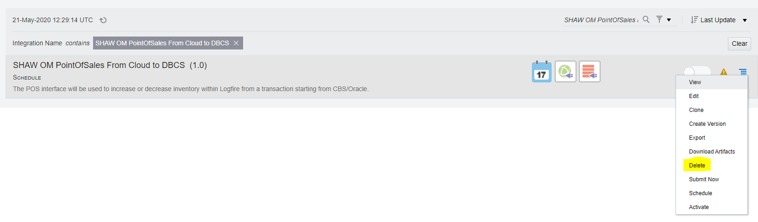

Click on hamburger symbol and click ‘Delete’

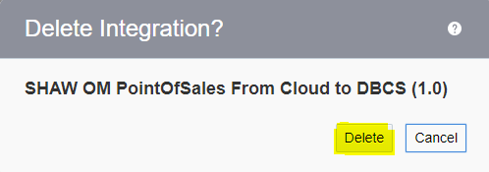

1. **SHAW OM PointOfSales From DBCS to Logfire**

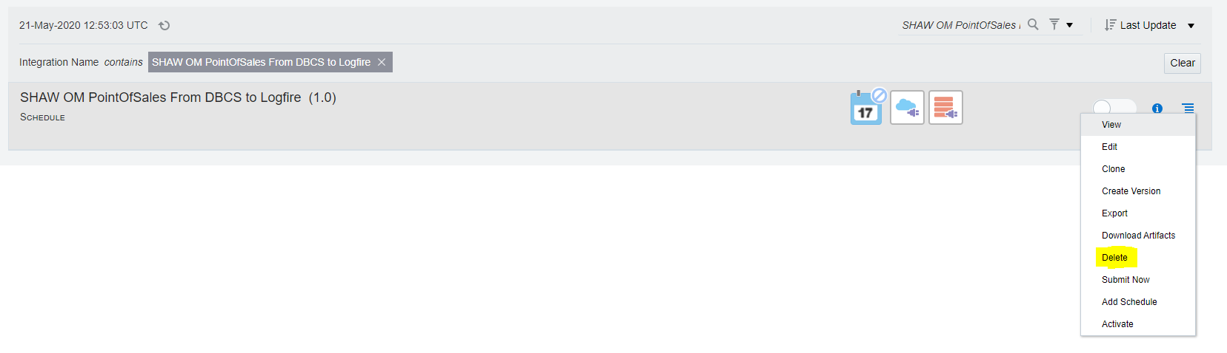

Click on hamburger symbol and click ‘Delete’

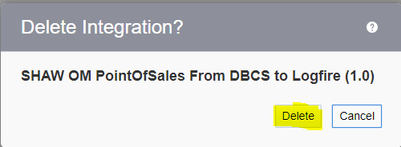

* Re-import the Lookup file: “**SHAW_Logfire_Common_Lookup.csv**” for “**SHAW OM PointOfSales From Cloud to LogFire**”from the backup file taken from “Backup Prerequisites”.

Step 1: Follow the following steps to re-import **SHAW_Logfire_Common_Lookup.csv**:

Go to the URL:- <https://shawicsprod-a444774.integration.us2.oraclecloud.com/ics/>

Enter the credentials and login

Go to Task – Integrations – Designer – Lookups

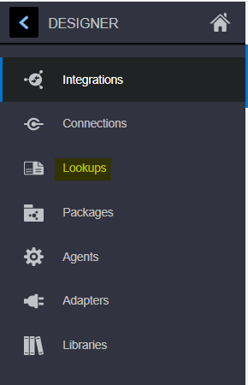

Click on “Import”



* Get latest csv from Git

Browse the **SHAW_Logfire_Common_Lookup.csv** which has taken as backup

* Click on Browse. select that csv and click on import





* Activate the integration **SHAW OM PointOfSales From Cloud to LogFire**

and activate it from backup code taken from **Backup Prerequisites** by following the

below steps:

STEP 1: Go to the URL:- <https://shawicsprod-a444774.integration.us2.oraclecloud.com/ics/>

Enter the credentials and login.

STEP 2: Go to Task – Integrations – Designer – Integrations and click Activate

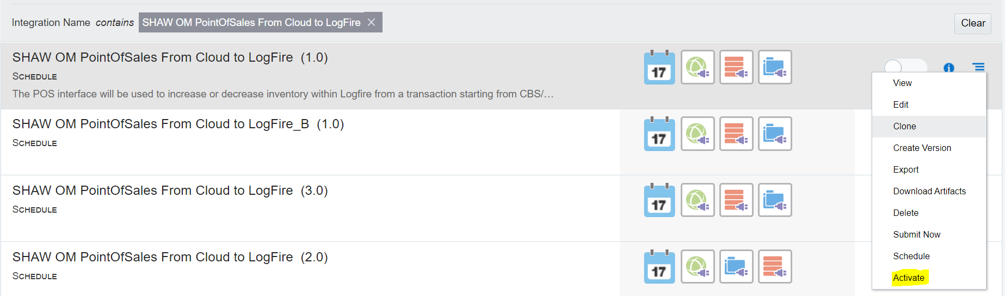

* Follow **Post Installation Steps** to activate master schedular integration.
* Delete Data Model from ERP:
  + **Step 1**: Go to ERP Cloud

URL: - <https://eguh.fa.us2.oraclecloud.com/analytics>

Enter the credentials and login.

* + Click on ‘Catalog’ on top of the screen



* + From the left side of the screen, navigate to the folder

/Shared Folders/Custom/Shaw Custom/Integrations/QueryService/Data Model/ SHAW_ERP_POS_DM

* + Select the Data Model: “SHAW_ERP_POS_DM”, click on ‘More’ and click ‘Delete’

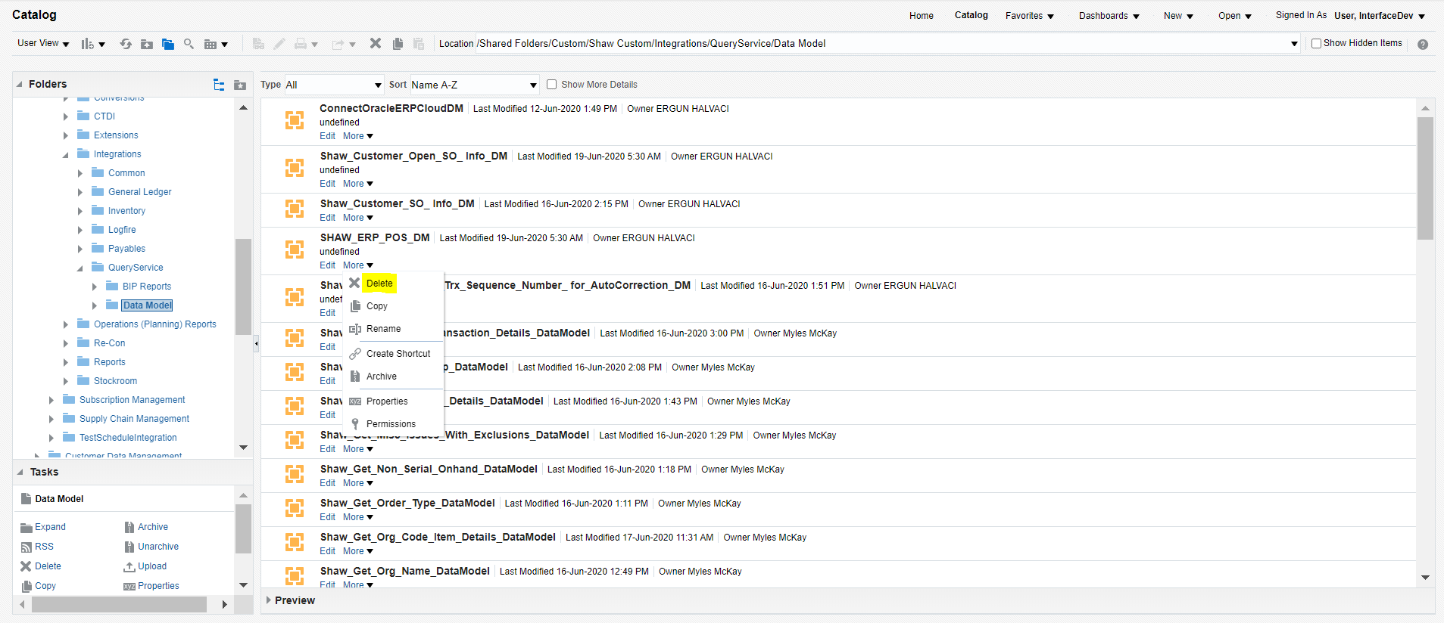

* + - * Click OK.

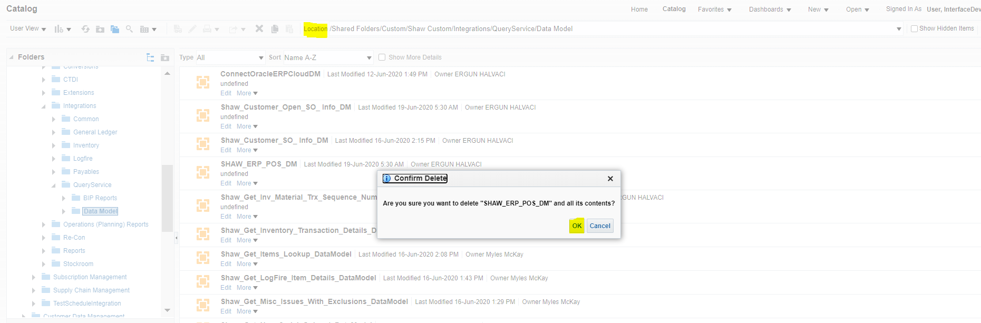

**Step 2**: Similarly, delete the corresponding BI Report from ERP.

* + From the left side of the screen, navigate to the folder

/Shared Folders/Custom/Shaw Custom/Integrations/QueryService/ **BIP Reports**/ Shaw POS Report

* + Select the Report: “Shaw POS Report”, click on ‘More’ and click ‘Delete’

